Lab program(22-32)
22. num <- 5

if (num > 0) {
print("Positive")
} else if (num < 0) {
print("Negative")
} else {
print("Zero")
}

a <- 10
b <- 3

print(a + b)
print(a - b)
print(a * b)
print(a / b)

print(a > b)
print(a == b)
print(a != b)
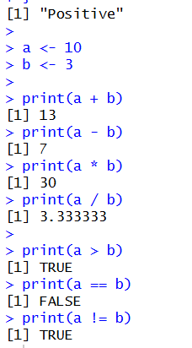
23. num <- 5

for (i in 1:10) {
cat(num, "*", i, "=", num * i, "\n")
}
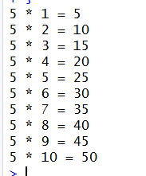
24. num <- 1234
total <- 0

while (num > 0) {
digit <- num %% 10
total <- total + digit
num <- num %/% 10
}

print(total)
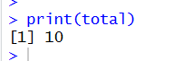
25. for (i in 1:10) {
if (i == 3) {
next
}

if (i == 8) {
break
}

print(i)
}
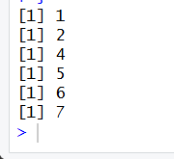
26. my_list <- list(a = 10, b = 20, c = 30)

for (item in my_list) {
print(item)
}

for (name in names(my_list)) {
cat(name, "=", my_list[[name]], "\n")
}
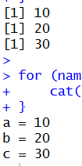
27. add_numbers <- function(a, b = 10) {
return(a + b)
}

print(add_numbers(5))
print(add_numbers(5, 20))
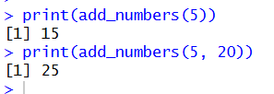
28. square_number <- function(x) {
x * x
}

cube_number <- function(x) {
return(x * x * x)
}

print(square_number(4))
print(cube_number(3))
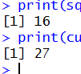
29. calculate_stats <- function(x) {
result <- list(
sum = sum(x),
mean = mean(x),
max = max(x),
min = min(x)
)

return(result)
}

data <- c
(10, 20, 30, 40)

print(calculate_stats(data))
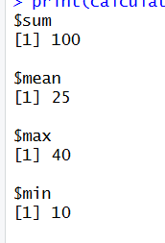
30. my_function <- function(x) {
x + 1
}

print(class(my_function))
print(my_function(10))

another_function <- my_function

print(another_function(20))
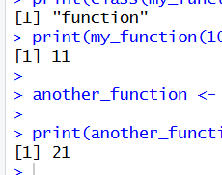
31. factorial_fun <- function(n) {
if (n == 0) {
return(1)
} else {
return(n * factorial_fun(n - 1))
}
}

print(factorial_fun(5))
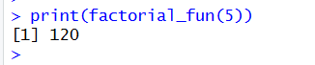
32. fibonacci <- function(n) {
if (n == 0) {
return(0)
} else if (n == 1) {
return(1)
} else {
return(fibonacci(n - 1) + fibonacci(n - 2))
}
}

n <- 10

cat("Fibonacci Series:\n")

for (i in 0:(n - 1)) {
cat(fibonacci(i), " ")
}
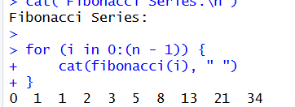
Result:
Hence the output is verified Successfully.

